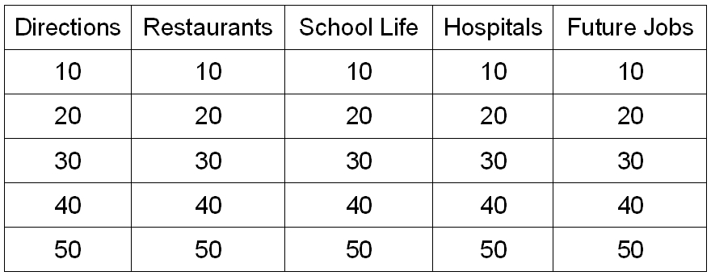
Jeopardy

Usual Rules:
- Prepare five questions on five subjects
- Give each question a point value
(10 for easiest, 50 for most difficult)
- Draw a Jeopardy board (see right)
on the black board
- Divide class into teams
- Choose on question on the board
- Ask the question
- Give the points for that question to the team who answered correctly
- That team can now choose the next question (“Directions for 30 points”)
- Repeat from (6) until all questions are answered
- Team with the most points wins

Improvements:

- add dice
- within each group, decide an order so each student has a chance to answer
- Other topics:
  - winter or summer holidays
  - Questions about teachers
  - cultural questions
  - world / current events
  - spelling
  - pronunciation
  - variety
  - English-speaking country names
  - kanji meaning to English
- Bonus chance for teams that are far behind (to catch-up)
- relative questions, so that for difficult questions the closest guess wins
- many winners (1st , 2nd 3rd) so not only top team gets prize
- to avoid groups choosing high value questions, start from top
- answers in complete sentences
- give slower teams a chance to answer questions, not just fastest to raise hand
Battleships

Usual Rules:
- Prepare worksheet with two grids (see example)
- Put students into pairs
- Students hide the bottom grid and add ships
- Students play janken to decide who goes first
- First student asks a question using phrases on top and side of grid
- If second student has a ship on the corresponding square, first student gets a hit
- Second student takes a turn
- Repeat until one student has hit all the opponents ships

Improvements:

- coloured print-outs, laminated
- more current title like “Pirates of the Caribbean”
- janken for each turn instead of back and forth (increases competition)
- use only as a review or warm-up
- have students make noises to accompany a hit or miss
- have students make up the questions
- have music playing in the background
Bingo

Usual Rules:
- Prepare sheet with a 5 by 5 grid
- Give each student a sheet
- Students write 25 numbers from 1-100 in their grid
- ALT draws a number from a bag and reads it out
- If a student has a number, they can circle it on their sheet
- If a student makes a line of five circles, they shout “bingo!” and can get a reward
- Repeat until timeis up of a set number of students have won

Improvements:

- Groups – students can talk instead of the ALT
- Interview game – use janken to decide winners
- Use Questions and Answers or sentences instead of numbers
- limit amount – 1 to 100 takes a long time = dull
Karuta

Usual Rules:
- Divide students into groups of four
- Give each group a set of cards with pictures on them
- ALT shouts out a word
- If a student can see the corresponding card, they grab the card
- Repeat until all cards have been won
- Winner is the student with the most cards

Improvements:

- Read words that don't express any cards
- Make an order in the group and alternate
- students shout the words, not the ALT
- Don't shout the words but the meaning of the words or give some hints
- Use different materials
  - use colour pens and let students mark it
  - fly swatters
Pictionary

Usual Rules:
- Divide students into groups of four
- give each group a marker and some blank paper
- one student from each group goes into the corridor with the ALT
- ALT gives students a word
- students return to their groups and must get the others in their groups to guess the word
- The drawing student must not talk and can only draw pictures (no letters, numbers or kanji)
- If a student can guess the word, they raise their hand and tell the teachers
- If correct, that team wins a point. If wrong, the other teams have a chance to guess
- In the next round, a different student goes to the corridor and draws
- repeat until time is up
- team with most points is the winning team

Improvements:

- Not enough speaking – speak while drawing (hints)
- more involvement – dengon style to relay message (like 'Taboo')
- give a sentence or phrase instead of a word
- everyone going at the same time
Criss-Cross

Usual Rules:
- Arrange students so they sit in a grid
- Have the first row stand up
- Show a flashcard to the students
- If a student knows the name of the picture in English, they can raise their hand
- If the student is correct, they can sit down.
- repeat until one student is standing
- The column of students in front of and behind that student also stand up
- Show flashcards and take answers until one student is standing
- The row of students to the left and right of that student also stand up
- repeat until time is up

Improvements:

- Use two to four groups in lines, all stand up. The first person of each line is to answer the question. Fastest to get it right can sit down. Everyone else goes to the back. Repeat. First group to sit down wins
Interview Bingo

Usual Rules:
- Give each student a sheet with a 5 x 5 grid on it and a short dialogue
- Each square on the grid has a phrase in it that can be used in the dialogue
- Students are also given a card with one of the phrases on it
- Students stand up and meet another student
- Students play janken to decide roles in the dialogue and perform it
- Janken winner can write the name of the other student in the square corresponding with the phrase used (which is on the other students card)
- Students try to make as many bingo lines as they can in this way
- When time is up, students with the most bingo lines win a reward

Improvements:

- Can only get the person's name if they have the activity in common
- gesturing the activity and having the other student guess
- catergories instead of set answers (e.g. study, play, etc)
- Time limits to make it more challenging
- color coding to make girls talk to boys
Activity Name: Pico Pico Hammer Game

Usual Rules:
- make groups of 4-6
- one of the members gets a hammer
- when the ALT says an English word, hit the picture on the black board
- fastest student gets one point

Improvements:

- use kanji instead of pictures
- the team member with the hammer is blindfolded and needs directions from the team
- 2 words combined, e.g. red apple, green apple
- Using English questions and hit the answers
- if a second person hits the right answer, and they can pronounce the word, they get points
- make circles and the first person goes to the teacher for the word, use dengon game and the last person gets the hammer and hits the answer
Activity Name:________________________

Usual Rules:

Improvements:

Activity Name:________________________

Usual Rules:

Improvements:

Activity Name:________________________

Usual Rules:

Improvements:

Activity Name:________________________

Usual Rules:

Improvements:

